THE VULTURES ARE CIRCLING

Poems About Love, Loss And A Society In Crisis

Michelle Torez

Copyright

Published in 2024 Copyright © Michelle Torez

Michelle Torez asserts the moral right under the Copyright, Designs and Patents Act 1988 to be identified as the author of this work.

All Rights reserved. No part of this publication may be reproduced, stored in a retrieval system, or transmitted in any form or by any means without the prior written consent of Michelle Torez. No part of this publication may be circulated in any form of binding or cover other than that in which it is published here and without a similar condition being imposed on the subsequent purchaser.

A CIP catalogue record for this title is available from the British Library.

About The Author

Michelle Torez is an established author, artist, motivational speaker and mental health campaigner who’s won various national and international writing awards. Due to enduring so much trauma and abuse in her life she’s become an inspiration for many people, especially to those who have been let down and abused in the corrupt UK mental health “system”. Her book 'Broken Doll' was ranked in the top 1,000 poetry books on Amazon UK due to its brutally raw depiction of abuse in an NHS mental health hospital. Michelle was born in 1994 in Hull, East Yorkshire, England and was raised by her loving and highly educated father. Tragically though, at the tender age of just twelve, she got locked away and sent around the country like a parcel to various units and hospitals. During her five year long incarceration at Roycroft Clinic in Newcastle Upon Tyne, she was abused in every possible way.

Michelle currently lives in Leeds, England and is still working on a book about her horrific childhood being locked away in the cruel, corrupt UK mental health “system.”

Other Titles By Michelle Torez

Broken Doll-Poetry And Artwork From The Mental Hospital
Poems About Love And Other Dangerous Things

Life Story Coming Soon

I was just twelve years old when I was locked away and abused for years in various UK mental health hospitals. When I was finally released, I was given very, very little support, despite being traumatized, scared and heavily institutionalized so, sadly, I ended up in a vicious cycle of attempting suicide, going to hospital and going to prison that lasted many, many years. The truth is that there isn’t a working mental health “system” in the UK. Desperate people are ringing crisis lines and, if they can get through, are hurried off of the phone by an obviously fed up “professional”. Desperate, suicidal people are being told to go to AE, only to be given leaflets and sent back home. We deserve better.

I wrote this book to raise awareness of what still goes on to this day and to inspire people to never, ever give up because things honestly do get better. You can download a free chapter by going to https://www.michelletorez.com

Art And Music

As well as being a writer, I’m an established artist and I sell my artwork on my website. My pieces usually expand on themes explored in my poetry.

Why not browse the collection today, you never know, you might just find a piece that speaks to you.
https://www.michelletorez.com/art-gallery

I’m also in the process of recording a rap rock album. You can check my social media for updates on this if you are interested.

Facebook- Michelle Torez
Twitter- MTorezwriting
Instagram- michelletorezcares

Thank you for picking up this book.
Please remember that, no matter how awful your situation may be right now, nothing, absolutely nothing, stays the same forever.

Never give up
Michelle Torez

The real demons are Human.

The real demons are Human.

The real demons are Human.

Be careful, be careful
the vultures are coming, they’re on their way,
to finish what they started
to devour their scraps of prey.

Smokescreens

Bodies draped in grey
surrounded by thick grey steam,
these days it's hard to tell who's human
and who’s actually a machine,
desperate people
evil, evil regimes
when the poor die nobody notices
it’s just paperwork
it’s just smokescreens.

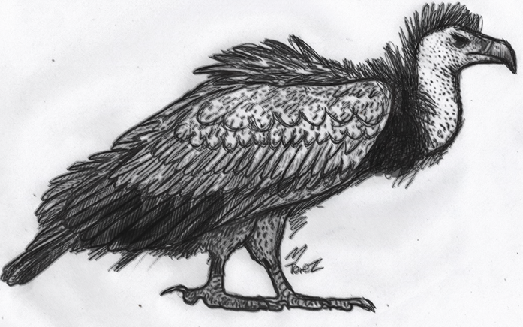

Ghost Eternal

I’m the ghost that haunts you daily
I’m the reason you wake sweaty, late at night,
I'm the creepy shadow in the corner
I’m the reason things don’t feel right.

I’m the ghost that haunts you daily
I'm the chill, the goosebumps that rise,
I’m the dread that eats you away
I’m the reason tears stay in your eyes.

I’m the ghost that haunts you daily
I’ll forever follow, lurking near,
I’m the guilt that’ll cause your early demise
I’m the source of your deepest, darkest fears.

I’m the ghost that haunts you daily
I’m the reason you scream and shake,
please live in fear, you’re my victim now
my childhood you chose to take.

A Forgotten Rose 3

We ignored it, let it slowly wither away
a brutal reminder of the things we didn't do
and all the things we wouldn't say
from blooming, growing
to on the floor broken yet again,
another dead rose to throw out
the cycle repeats itself again.

Fake

In an ideal world, our smiles are real
and our feelings aren’t wrapped up in cotton,
in an ideal world, I’m more than just a novelty
that’s exciting today, but tomorrow forgotten.

I Used To Paint You

It hurts when I think of your face now
those sunken eyes, that pasty complexion,
I wish I could’ve controlled my feelings
my thirst for love and affection.

Those cigarettes, those trails of poison
you always said they’d send you to the grave,
then you’d finally rest with the angels
who'd offer you respite from life’s cruel ways.

You sold my paintings for clothes and food
and things you thought I'd never find,
it burns through my eyes, such horrible times
watching both your body and brain decline.

I’ll never paint again though
as every canvas gets ruined, blood always stains my hands,
I wanted to take you away from that horrible cardboard home
but you just didn’t seem to understand.

I remember the day you kissed me
because, in a whisper, you told me it numbed your pain,
I had danger written all over me though
and what happened afterwards I can never change.

It makes me nervous when I think of your voice now
oh that laugh and that harsh northern tongue,
I wish I could understand why I did what I did
but I guess what’s done is done.

It hurts when I think of your face now
those sunken eyes, that pasty complexion,
I wish I could’ve controlled my feelings
my thirst for love and affection.

I’ll never paint again though
as every canvas gets ruined, blood always stains my hands,
I wanted to take you away from that horrible cardboard home
but you just didn’t seem to understand.

In Heaven Let's End This Yearning

Please come down from the clouds
and please plant a kiss on my cheek,
I’ll never ask for your lips
but that euphoria you know I seek,
can I please hold your hand?
as I know your soul is burning
I love you
I want you
I need you
in heaven we can end this yearning.

Gaunt Faces

Gaunt faces, ignored places
those at the top just pass the blame,
broken souls lay on cardboard boxes
constant deprivation, always the same,
sadness, pain and fear
everywhere we now turn,
people are being lied to and manipulated
when will they ever learn?

Foodbanks And Grief

Hood up, try walking alone
down these blood stained streets
too many are proud to call their home,
it’s foodbanks and grief
and it’s heartache and receipts,
us at the bottom just get crumbs
I'm so sick of this deceit.

Every Time You Fall

It hurts every time you fall
oh I keep telling you not to climb,
I can't pick you back up forever though
can’t you see you are running out of time?
how can you just sit there laughing
laughing yourself to sleep?
whilst I sit here shaking with worry
wading these waters deep.

With You

With you I check the corners and edges of things
to ensure there's nothing that can harm,
with you due to all the incidents
my mind is ever so quick to alarm,
with you I tear up photos
with you I plan for the worst,
with you I've never felt so desperate
come on darling, quench this thirst.

Stick Thin

Stick thin bodies
curled up in shop doors,
no doubt they'll soon be arrested
for breaking the latest laws,
no compassion or understanding
will ever be found around here,
gone any sense of community
all around now, pain and fear.

Austerity 2024

Hungry kids crying
voices muffled by those that lie,
if you’re homeless it’s your own fault
we don't want to see it,
so don't ask why!
evictions, screams and gunshots
happen at six or one or three,
some say the rich get richer
while some say just let it be.

The Haunt

Please stop haunting me, please refrain
from showing me that red building down the back of Jubilee Lane,
with windows dark and secrets untold
a place where demons dance and souls turn cold.

In the dead of night, the creatures do whisper
echoes of anguish, a haunting, persistent quiver,
the walls hold memories, all disturbing and grim
of shattered dreams and lights that went dim.

Squashed, stretched and beaten, like putty in hands
I'll never forgive the abuse, the evil, evil commands,
for in every inch of that building, darkness did reign
and the sounds of desperate screams shall forever remain.

Haunted by demons, I now tread with care
through everything in life, as they still breathe my air,
they linger beside my bed when it’s time to close my eyes
and they whisper me disturbing ideas and lies.

But, despite this, I somehow still find strength
to keep on going, no matter the length,
and with every single setback and with every single blow
my courage and determination only continues to grow.

So do not haunt me anymore, I plead
for I'll face the shadows, and with courage, I'll succeed,
despite evil lurking at night and even through day
I’ll stand tall and speak my mind, I’ll never be turned away.

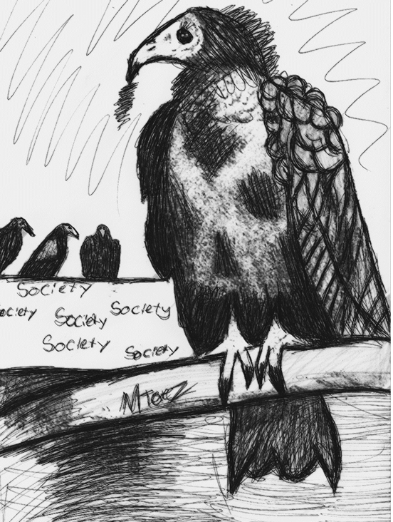

L The One?

You get prettier and prettier daily
so deeper and deeper I do fall,
but it’s just no use for either of us
because you simply don't want me at all,
sometimes it just never feels right
even if the feelings are strong,
it's life, it hurts, I fancied you after a second
but from the start it was all so wrong.

Obsessed

They say I’m obsessed
and to be honest, I know they’re right,
I fixate on names, I inject hope into my veins
to keep myself up at night,
I overdose on fabrication
I lie to myself more and more,
knowing the outcome will only be pain
but still, I can't shut the door.

Lies

Ominous dark red glows
loneliness that claws at souls,
to cope, they advise we take another pill
or download another app on our smartphones.

A slave to AI and bots
and as naked as the day we were born,
we search for connections, friendships
whilst over and over we just get torn.

Coward

I told you that I loved you
and your response was to block me, goodbye
your cowardly way of saying it was over,
but you just couldn’t tell me why
so the screen went dark and my heart did too
and left in total desperation, my anger grew and it grew.

I poured out my soul on paper and to your face
but your cowardly response was to just leave and try and erase,
any memory I ever existed
any ideas my feelings were true
you hurt me and you changed me,
yet I’m still in love with you.

L Is Not For Love

I always talk of shattered things
broken promises, discarded rings,
those that vanished without a trace
those that found joy in lying to my face,
those that viewed revenge as the solution, the goal
those that didn’t believe that they completed my soul.

I always talk of shattered things
the way the words echo, the way her name rings,
blocked on twitter, blocked on phone
blocked from coming over, blocked, just leave me alone,
blocked from caring, blocked, too close
traumatized by love, triggered by most.

I always talk of shattered things
guilt-soaked skins, denial tinged gins,
those that vanished without a trace
those that found joy in lying to my face,
the woman that I’d die for, the woman for my soul
the woman that ran off and became my only goal.

LLLLLLLLLLLLL

You’re everything I ever wanted
you fulfil my every need,
whilst in your presence I’m ever so happy
but in your absence I just sit and bleed.

Sinister

The aching in your bones is me
and the stabbing in your chest is me too,
we receive these medals as we soldier on through life
wear them with pride, my gifts for you.

The anger on the tip of your tongue is me
and the sadness in your soul is me too,
you live and you learn from every person in this life
oh I’m only doing this to help you.

The hopelessness on your wrists is me
and the ache from wading water, that’s me too,
it gets easier with practice, practice makes perfect
please make use of my gifts for you.

As January snow drifted down and settled on roofs, two birds perched on the razor wire. Despite being so, so desperate for a fresh start, deep down inside I knew the horrible, harsh reality that the only thing that’d be changing would be my cell number. Soon, ever so soon, my soul would be in complete darkness.

Evil

The vulture, the vulture, I know he's on his way
when the temperature drops and on my knees I do pray,
and through the gaps in windows he blows hard to chill
and scare and harass, his only real thrill.

Half man half thing, all soaked in dread
full of sadness and shame for the things left unsaid,
so when his mouth opens, the trees all quake
he quenches his thirst, and everyone around begins to shake.

Sometimes at midnight, I can feel his stare
even through brick, I just know that he’s there,
he appears from a place where limbs are cut and then cast
he’s the ruler of the dark, his realms infinitely vast.

The vulture, the vulture, I know he's on his way
when the temperature drops and on my knees I do pray,
half man half thing, all soaked in dread
full of sadness and shame for the things left unsaid.

Crazy

I will chase you and track you
and I don’t care if it causes you fear,
I’m in hunting mode now so be careful
as I get a kick when I know that you’re near.

I will follow you and watch you
until your cramped house becomes a jail,
and you hide in the corner with all the lights off
so in darkness you’ll be lost and frail.

I will torment you, haunt you
every night when you try and sleep,
what you did to me was so brutal, evil
that still to this day I weep and weep.

I will send you letters, send you parcels
until a restraining order is put in place,
I’ll text and text and turn up unannounced
until bags and lines cover your face.

I will want you and desire you
until my last breath, until the day I die,
but you lied to me and then you discarded me
and still to this day I don’t know why.

People Are Scared of Love

In films people find it cute, love at first sight
but in reality it scares them, they say it’s just not right,
the intensity, the rush, they find it rather scary
so they hide their emotions, feeling vulnerable and wary.

A love so sudden seems rather hard to bear
so most guard their hearts, filled with guilt and despair,
for sadly it’s not the sweetness of love that they see
but someone who’s desperate, too emotional and needy.

Some hearts are too wounded, too scared to ever believe
that they actually deserve love, so they struggle to ever perceive,
how someone could actually fall so fast and so deep
so most run away, to escape from the “creep”.

But people should judge less and listen so much more
for love has no limits, it opens every door,
so instead of running, let's all embrace the unknown
and cherish every bit of love that we've kindly been shown.

But nope, in real life, love causes such shock
I’ve been told I’m strange, obsessed then blocked
it's not seen as cute, but a danger, a warning sign,
so hearts get broken and people get left behind.

No Mans Land

Between the pillars of right and wrong
I swear, lie and be anything but me,
the grey area that I rarely talk about
weighs me down, stops me from being free.

The Truth About Me

Pain has changed me
I now push when the urge is to pull,
I now run when I know I should stay
every time I sleep I’m in nightmare,
I never see in colour, always the grey.

I Keep Going Back!!

Begging for breadcrumbs of affection
all tangled up in thoughts of shame,
surrounded by blood, glass and really bad vibes
in broken reflections I repeat your name.

December

December came and visit day arrived
and in a small, sterile room they cried and they cried,
the view from the window just razor sharp wire
and naked trees and bushes that seemed to shiver and tire.

Due to cackling and plotting, just a few weeks before
she became an official prisoner, many times she broke the law,
so the days once filled with laughter and pride
were gone, long gone, the good in her had died.

From roaming the streets with weapons and rage
to being confined to an institution, her spirit was caged,
regret weighing so heavy, near impossible to bear
she reflected on the choices made in moments of despair.

December came and visit day arrived
and in a small, sterile room they cried and they cried,
the view from the window just razor sharp wire
and naked trees and bushes that seemed to shiver and tire.

With puffy bags under eyes from nights without sleeping
she ponders promises made, not one of them worth keeping,
whilst he worries about his daughter with every passing day
hoping one day she finds happiness, she one day finds her way.

The Lights Went Out

The wind screamed and cackled
and made lots of unsettling sounds,
while she sat alone in a prison cell
permanently gagged
permanently bound,
a light flickered in the east
then a light flickered in the west,
but then they both went out
the staff say they tried their best.

Cageling

With just one punch
and just one scream,
she quickly tore the world apart
labelled an angry, evil being,
with fists pounding and pounding
the snow quickly turned red,
then she was locked away forever
to be abused and left for dead.

The Truth About The UK 2024

There’s no pot of gold near the rainbow
sorry to be the bearer of bad news,
but I don't do fabricated niceties
nope, I just simply refuse,
to dance around the edges of meaning
to tiptoe around the truth,
this government is culling the vulnerable
and destroying any chance for the youth.

Be careful, be careful
the vultures are coming, they’re on their way,
to finish what they started
you won’t see another day!

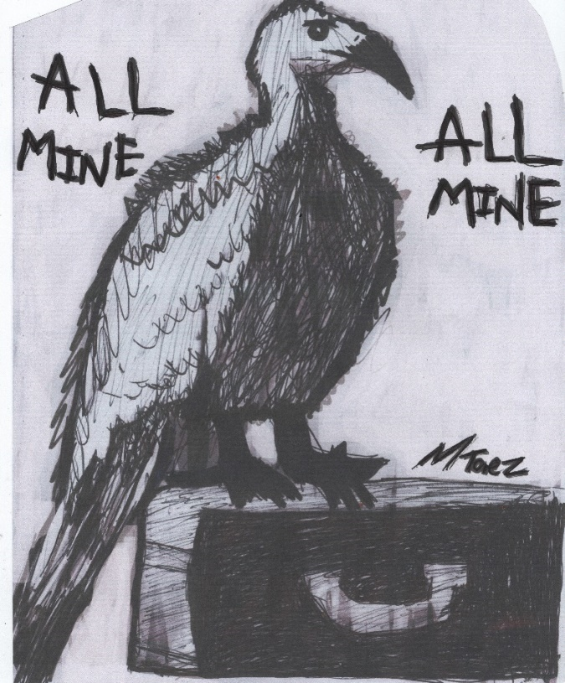

Never Enough

I'm in that paralyzed, stay still kind of love
that want what you can't have kind of rush,
I would walk on glass to protect her
but I know that nothing will ever be enough!

Unlikely

Kiss me on the sofa
tell me you feel the same,
but yes I know it's unlikely
so I scold myself when I say your name,
now when my mood crashes like waves
now when the wind blows strong
I tell myself to stop
I tell myself to move on.

Down This Dead End Avenue

Down this dead end avenue
kiss me, call my name
tell me that after three years of waiting, longing
that you finally feel the same,
come on, let's make memories together
let's build, let's combine, let's rise
I'll pretend that you're the one for me
and I'll feed off of all your lies.

Please Give Me A Try

No need to be scared of my love girl
please oh please give me a try,
this raging inferno is under control
so please oh please look me in the eye,
no flames will burn your skin
no flames will scorch your heart,
I love you I love you I love you!
so please oh please don’t depart.

I’ll Let The Sun Set On My Regrets

I'll let go of the things I didn't say
and all the things that I just couldn't do,
I'll let the sun set on every one of my regrets
as I hold her close, start something new.

Goodbye

Goodbye to my life of solitude
surrounded by so many faces,
goodbye to the torment and abuse
demons, supervised spaces,
never had a home or shelter
hospitals and prisons my entire life,
so I'll soon go back to the elements
because nothing can ever make this right.

Fling Addiction

I advance and she winks, a signal, it’s green
to give pleasure or receive, I’ll always be keen,
to kiss, suck or fuck, at any given chance
a social pariah starved of romance.

Sex, cum, done, a fleeting escape from the abyss
no love at all, just a temporary bliss,
just a means to an end, no more, no less
it numbs my pain, watching strangers undress.

The time I revealed love, she ran away, scared
maybe she wasn’t attracted, maybe she was just unprepared,
to meet someone so honest, real and loyal to the bone
so, I just do flings now, I’m preparing for a life alone.

Transient treasures, walls of skin
faking it on a bed full of knives,
unanswered calls as we do the devil’s dance
this is what became of our lives.

Nightmare (I Pray And Pray)

I loved her within five minutes
that’s a fact that I know for sure,
a single chat and I knew she was the one
never before had I felt a love so pure.

But sadly, the devil interfered
and evil spirits came to cause pain,
Medusa haunted me with bloodshot eyes
no longer confined to a wooden frame.

I tried to ignore it, I honestly did
but the pressure was just way too strong,
with spirits constantly saying she was in danger
her house was on fire and something was wrong.

But after two months of trying to resist
I awoke on a train in Kings Cross Station,
and totally under the spell of sinister creatures
I ordered a taxi to her home with no hesitation.

House in sight, I knew I had to be quick
because black dangerous orbs were all around,
the evil spirits were multiplying by the second
plotting evil and heinous acts without sound.

So, I bravely knocked on the door
preparing to fight whatever was lurking inside,
I clutched my protection necklace and said a few prayers
as her father reluctantly stepped outside.

“Please remove the box and painting
you’re in danger” I said loud and clear,
but with a nervous smile he just shook his head
and replied, “I’m not, please don’t worry dear.”

“I know your struggling, but your too intense”
he said with guilt in his eyes,
“my daughter and wife have problems too
so that’s why they said their goodbyes”

So, getting nowhere, I rang the police
and told them, urgent situation,
they arrived within five with pale white faces
and approached with obvious hesitation.

And after explaining my concerns and blessing them both
the two bravely went inside,
and whilst standing alone in the bitter cold and snow
I let out my emotions and cried.

All I could see was flames and fire
and all I could think of was save her, save,
I felt sadness for the family, so ignorant and angry
knowing very soon they’d meet their grave.

But within fifteen, the police came out
and asked me to sit in their car,
“We’re concerned about your mental state and so are they
it’s rather worrying you travelled this far.”

They told me that she wanted me gone
and I was never, ever to return,
no texts or calls would ever be accepted
and with anxieties heightened, resentment burned.

“You need help, you’re not well”
the police woman informed, holding my hand,
but I just couldn’t see it, I was away with the fairies
I was living in a different land.

And as they drove to the AE in Dunstable
intense pain, it burned my soul,
I risked my life, yet I was being punished
so my mind retreated into its dark hole.

A few weeks later, when I eventually woke up
I played The Roots “Now Or Never”, what a song,
the lyrics about never giving up despite all of the pain
and I quickly realized that my actions were wrong.

Surrounded by patients and medication
I realized there wasn’t a curse, there weren’t any ghosts,
just creatures conjured up out of my pain and fear
whilst trying to keep my loved ones close.

Now guilt still remains in my soul
for causing fear whilst trying to be kind,
I still truly care for that family, yes I really do
because they were a special, special find.

Now two years later, my soul still aches
and tears, they still fill my eyes,
for I met four people that I truly do care about
and yet again, my illness told them lies.

What hurts is that I wasn’t given a chance
just to simply be myself,
as soon as I met them, I became very, very sick
I’m plagued by PTSD and poor mental health.

For they believe that how I was then
is just how I am, the natural Michelle,
a terrible listener, rude and inpatient
but I was unwell and going through hell.

I hope one day they’ll forgive me
and I hope one day they’ll believe and try,
to see my kindness and not just my evil illness
because I’ll love them until the day that I die.

I Thought She Was My Soulmate

Embers in the dark, two damaged souls,
how long before red turns to grey?
fake yesses, smiles, walls of denial
one promises to never push away.

A breeze then it’s gone, one soul all alone,
why say things you don’t really mean?
fabrication vs the need for brutality
a girl begging for a love that’s clean.

I Walk Across Bridges That Burn

I walk across bridges that burn
I try and find truth in your lies,
twisting, turning,
forced into painful positions
fresh tears daily stinging my eyes,
every bridge burnt down
only ashes now remain,
yet I'll still go back for more
the cycle remains the same.

Scared

Stay just a little longer
don't just crawl back into your hole,
let's make memories together
damn you do something amazing to my soul,
I understand your scared girl
but listen, my words are true,
I'm here to stay
I'll prove it every day
damn I'm in love with you!

I Will Always Love Her

Sometimes the one you love
will never, ever love you back,
no matter what you say
no matter what you do
for it's the spark that lacks,
so I'm always running behind her
unable to ever get near,
eyes wide open, hope always in heart
she’ll always reject me, she made that clear.

No Coming Back This Time

Sever the connection
sever the vein,
drain me of this fear and hatred
so I can be reborn, start again,
sipping caffeine like water
my blood now red wine,
in slow slips of silence I’ll fall
there’s no coming back this time.

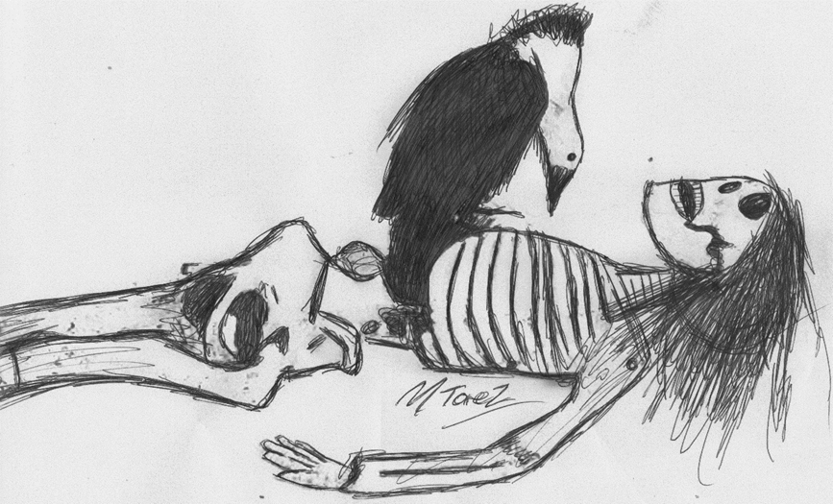

LOST

Black suddenly leaked into the pale blue sky
as I outstretched my arm and wondered to myself why,
I’d found myself back in the same old hospital bed
when I didn’t want to live, but I didn’t want to be dead.

The birds were all lined up along the barbed wire fence like ornaments and I was so, so worried about them that it hurt my soul. I just couldn't stop thinking about their wings getting slashed, whilst the Dr was writing reports about how much of a dangerous, evil monster I was.

Barbed Wire (Cute)

Four blackbirds lined the barbed wire
and simply caring about them made me smile,
amidst the chaos, my mind drifted away
to a safe haven we all could stay for a while.

Feeding Frenzy

They circled me then fed off of me
like starving flies on fresh shit,
they pecked at me daily like vultures
I was bitten, spat on, kicked,
power whores bruised me daily
nightmares constant, bloodshot eyes,
I will never forget the torment
the neglect,
the blood
the lies.

Damaged Goods

Touched by hand after hand
like a letter with no clear address,
passed around, damaged and ripped open
no privacy and so much mess,
twenty years later I’m still here
and people say it’s amazing how I survived,
but horrible visions haunt me daily
so to be honest, I’m barely alive.

F U

You told me I deserved it
as you punched me and spat in my face,
and I believed every single word
as I was malleable and out of place,
you abused me, you broke me
so the damage will always remain,
forever haunted by your words
I'll just never be the same.

As soon as I closed my eyes, my soul escaped through the open window. It flew over ten barbed wire fences, across a dozen big cities lit up by a zillion lights and right across oceans that had barely been explored, but, all too soon, it found itself back in that tiny room again, weeping, aching, longing.

Elizabeth

Shuffling down the white hospital hall
I caught site of a lady, dark haired and tall,
a single smile then she was dragged out of sight
and thrown into a cell that had zero light.

Thoughts of Elisabeth often fill my mind
as her soul was too gentle to be eternally confined,
my eyes open doors and my hands wave and wave
hoping to see her once again, and this time to save.

The maze of corridors, grimy and grim
haunt my existence now, chill me from within,
Elisabeth, gorgeous, I’ll forever think of you
in this horrible, evil world that's forever lost its hue.

Mo screamed and dropped to her knees when she discovered that her teddy bear had been brutally murdered. He’d been sliced right down the middle and all of his fluffy white guts were leaking out all over the place. That night I cried and I cried and I cried. The staff took the piss out of me. They kept telling me that I was way too emotional.

They Say I’m Too Emotional

They say I'm too emotional, too quick to shed a tear
too quick to feel happiness, too slow to feel fear,
too quick to fall in love, too quick to show care
is it wrong that I’m a kind girl who lays her soul bare?

They say I'm too emotional, because, to them, caring is wrong
but I refuse to be a sheep, I just refuse to play along,
in a world that suppresses kindness and encourages superficiality
I will forever embrace empathy and shun hollow formality.

Pain. It’s everywhere. Every time you set foot outside it manages to get through the tiny little holes in your clothing and sink all the way through the layers of your skin. Desperation. No matter where you go, you can’t hide from it. You can hear it, see it, taste it, smell it. People aren’t being listened to. The people at the top don’t care. People are dying.

Karma

Death is not the end
it’s simply the soul leaving the shell,
to be taken to a place the spirits deem suitable
it could be heaven
and it unfortunately might be hell.

Death is not the end
but simply a passage to the unknown,
where shadows dance and immortal spirits roam.

Death is not the end
but simply the beginning of a brand new phase
where souls find solace in strange and mysterious ways.

Death is not the end
it’s simply the soul leaving the shell,
to be taken to a place the spirits deem suitable
it could be heaven
and it unfortunately might be hell.

They Did This To Me

I now sleep with a knife in my hand
I now sleep with a gun beside my bed,
I now watch murder documentaries every single night
until my eyes close and the world turns red.

I now dream of following it through
I now dream of forensic teams clutching at straws,
I now stand outside the houses of demons and angels
staring at locks, trying handles of doors.

Evil is everywhere. A permanent headache, a debilitating sickness, a global disease. Guns, bombs, greed, hatred, war. Demons, Devils, Goblins or whatever else you'd like to call them, can be found right here on Earth. Humans. Just look at what we are doing to each other.

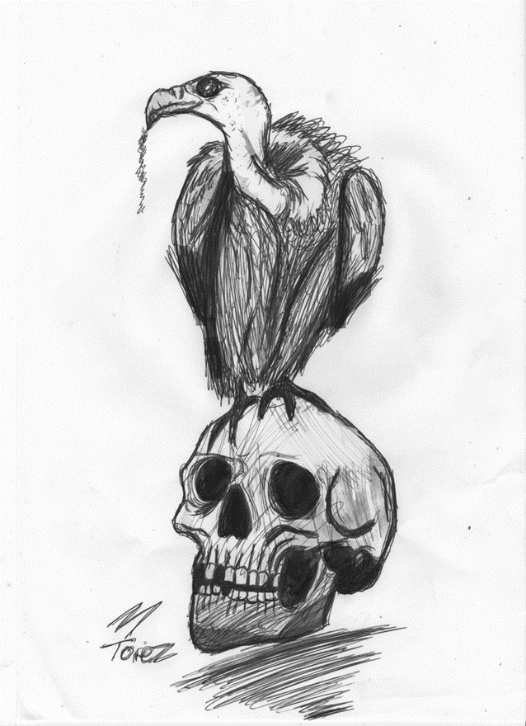

I Just Never Changed My Ways

Rose tinted memories
headphones muffling screams,
when I clutch at straws
a smile always seems to beam,
hoping for change
but unwilling to rearrange,
they always tell me shame
that I just never changed my ways.

Be careful, be careful!
the vultures are coming, oh they’re very close now,
I’d run away if I could, and I wish that you would
because me, well, I honestly don’t know how.

He's staring at me. I can feel his eyes through the brick, through the glass. He's standing out there in the courtyard where naked limbs that reach out from the Earth are cut off and thrown away. When he whispers my name, the wind howls and everything goes red.

It’s him.

The vultures are circling.

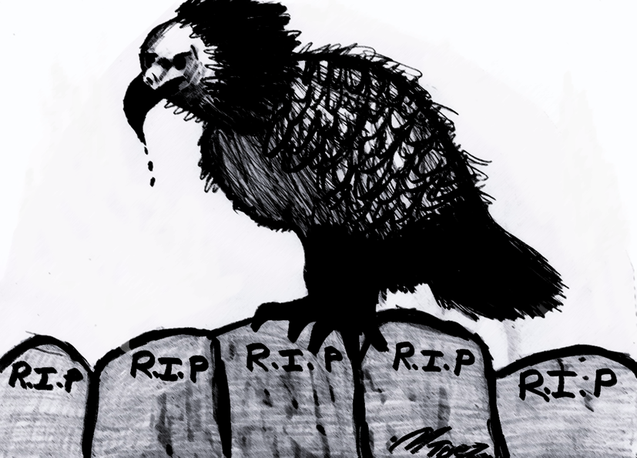

If you enjoyed this book please leave a review on Amazon thank you ever so much x
The link to copy and paste is www.bit.ly/vulturesmt

