Poems About Love
And
Other Dangerous Things
2021 Edition

(Free Preview Version)

Michelle Torez

About The Author

Michelle Torez is an established author, artist, motivational speaker and mental health campaigner. She has won various national writing awards. At just twelve years of age, Michelle was locked up and abused for over five years in a mental health unit in Newcastle called ‘Roycroft Clinic’. The abuse that went on there was uncovered in various newspapers and TV documentaries. Michelle is working on her debut memoir which details went on and how she survived.

Raising awareness of the lack of mental health care in the UK is Michelle’s passion. Millions of people are being sent away from crisis teams and end up killing themselves, while some are getting trapped in hospitals for years and years being sexually and mentally tortured. Michelle has created a support and campaigning group called ‘Fighting For Better Mental Health Services In The UK’ which is gaining momentum. If you have been let down by services, know someone who has, or simply want to join to make friends and campaign, feel free to join the support group here:

www.facebook.com/groups/fightingforbettermhuk

My Novel Based On My Horrific Life Story
Is Coming Soon

I was just twelve years old when I was locked away into the corrupt, cruel UK mental health system and abused for over five years. When I was eventually released back into the community, I was institutionalized and given very little support.

This book details what exactly went on and how I actually survived. If you’d like to download a free sample of the upcoming book, go to www.michelletorez.com

I Only Spoke To You

I only spoke to you
never did our hands touch, never did our lips meet
I imagine they would feel soft, tender
and taste of your favourite gum, minty and sweet.

I only spoke to you
and never did our words really mean anything,
apart from time passing, idle chatting
I only spoke to you about the world
never about the importance,
you with me,
and do you want to know why?
I knew you didn’t care less really.

I only spoke to you
yet, I wanted so much more,
you and me snuggled under warm blankets
behind a reinforced, double locked door,
but, although I hate it, the thought that your now gone,
your words help to remind me that
what feels so right can be
oh so wrong.

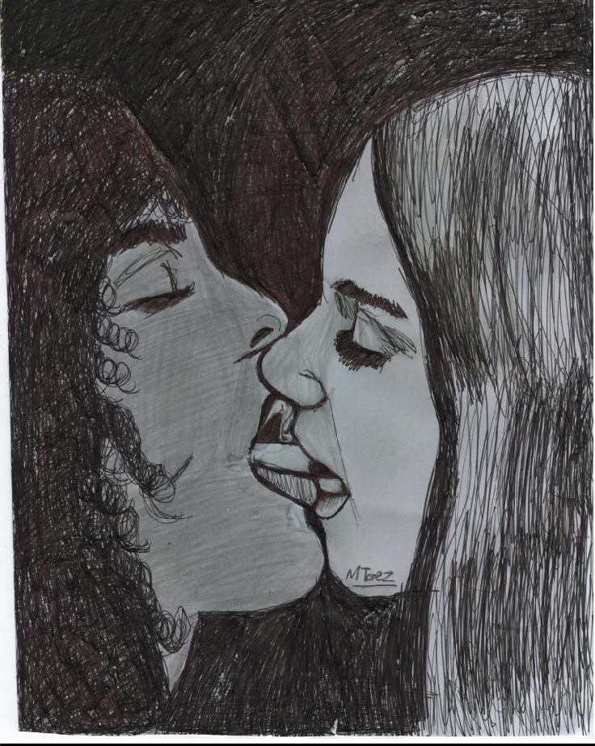

A Forgotten Rose

A forgotten rose, dying of thirst
in the corner of such a beautiful room
hope for us dried up like dead petals,
we are now surrounded in nothing but gloom
I stopped wanting to nurture you, protect you,
without a single tear in my eye
you abused me and you broke me, so now go wither and die.

Heartbreak, rejection, heartache
I’m just not prepared to feel anymore,
I have no more parts of my soul in which you can break
there is nothing left of my heart to manipulate, smash or take
bend and break
I have nothing at stake.

The way you flaunt what you don’t have is embarrassing
you crave the truth so listen carefully
as I state this one last time,
like an old photograph that’s curled at the edges
darling you’ve had your time to shine.

A forgotten rose, dying of thirst
in the corner of such a beautiful room
hope for us dried up like dead petals,
we are now surrounded in nothing but gloom
I stopped wanting to nurture you, protect you,
without a single tear in my eye
you abused me and you broke me, so now go wither and die.

No Interpreter 2

Visualize everything that makes you who you are
visualize everything that makes your life bearable
in this icy existence,
then throw it into the fire, those ever so seductive flames
you’ll become me, a heretic reciting names.

This world is as foreign to me now as when I was born
no words I speak could ever make sense to you
no words you speak could ever make sense to me,
this grief has trapped me in one time, one place
and I’m not sure if I want to be set free.

So please just watch my tongue flick like a snake
so please just watch my mouth
as it twists and it turns
visualize everything you ever wanted
then sit back and watch it burn.

No Interpreter 3

You tell me I don’t make any sense now when I talk
and it’s suddenly changed,
the way I present myself, the way I walk,
you tell me you’d like an interpreter to understand my speech
but I’m sorry, there is no interpreter,
not for this language of grief.

Between A Rock And A Hard Place

She’s stuck between a rock and a hard place
not wanting to hold it all in
but at the same time, not wanting to cry.

She’s stuck between a rock and a hard place
not wanting to exist
but not exactly wanting to die.

He Let A Demon In

His once delicate voice
now so harsh and deep,
he let a demon in while dreaming
he couldn’t fight it, far too weak,
he now talks about suicide and has fantasies about death
I just hope he says goodbye to me, before he takes his final breath.

My heart aches and aches
he doesn’t hug me like we’re in 2005,
I don’t mention it though, he’s hurting
and I’m just grateful he’s still alive,
when we touch he’s freezing, he makes my body far too cold
what’s inside of him isn’t human, stolen, gone is his soul.

He doesn’t have long left
the darkness has a tight grip on him
he’s drained, he’s empty, he’s hurting
so he’d rather drown than try to swim
we talk less and less as the weeks go speeding by
I’ve faced the tragic fact that that soon he is going to die.

His once delicate voice
now so harsh and deep
he let a demon in while dreaming,
he couldn’t fight it, far too weak,
he now talks about suicide and has fantasies about death
I just hope he says goodbye to me, before he takes his final breath.

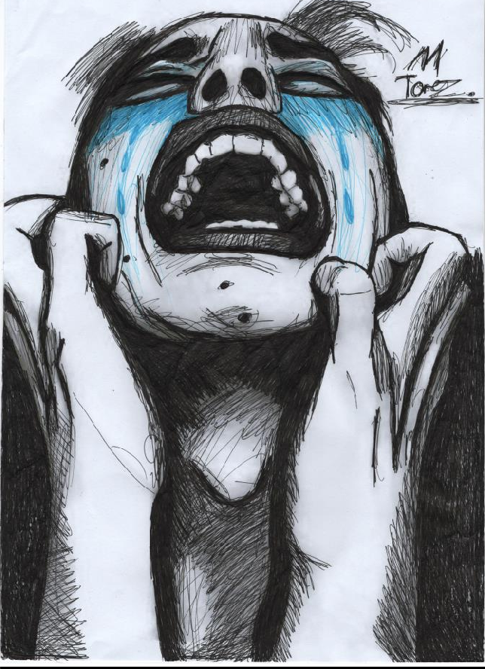

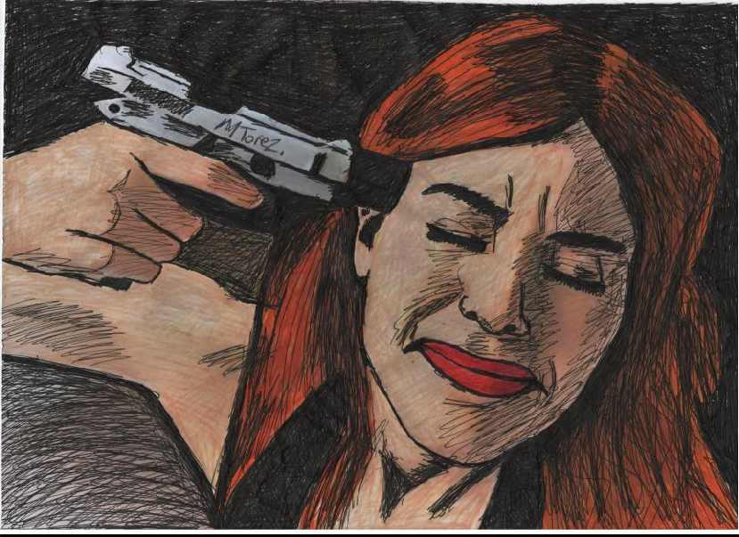

It Was The Pieces That Couldn't Fit

I saw her in such beautiful full colour
when she could barely even see me in grey,
I pretended the ink on the love letters were dry
before she had finished what she truly had to say.

I chased her out of habit
it was the inner torment, the flirting with pain,
it was the lack of intimacy that kept me hungry for more
it was the pieces that couldn’t fit that I framed.

Loneliness is a powerful force that always lingers
a dark entity disturbing my sleep,
I dreamt we were a couple and we could be happy
lying to myself is my coping technique.

I saw her in such beautiful full colour
when she could barely even see me in grey,
I pretended the ink on the love letters were dry
before she had finished what she truly had to say.

Now it’s time to lock that door
now it’s time to end the game,
now it’s time to sit alone in a room
without the need to recite a name.

I chased her out of habit
it was the inner torment, it was the flirting with pain,
it was the lack of intimacy that left me hungry for more
it was the pieces that couldn't fit that I framed.

Escort

I invite her in, she strains a smile
for an hour I’ll pretend sex is all I need,
I unhook her bra as she looks at her watch
fifty minutes then she can leave.

I kiss her with a passionless guilt
I chill her with my cold embrace,
when we fuck I think of someone else
so I can’t even look at her face.

I tell her to stop when I’ve cum
she doesn’t get to, this is about me,
she’s done her job and I’ve done mine
distraction from the pain of being empty.

She opens the door to the black
‘thanks’
door shuts, loud thud,
she slips quickly into the darkness and so do I
fantasies of suicide, a thirst for blood.

Thanks for reading. If you enjoyed this work, here are two ways to buy this book:

You can buy direct from me, signed, via www.michelletorez.com/shop

You can buy direct from Amazon here- www.bit.ly/palaodt21

It would really help me if you could review it on Amazon

Thank you, never give up and peace
-Michelle

